Using antonyms to alter character and setting

We can make a dramatic difference to a text by changing just one word. For example:
- Zak looked over and smiled cheerily.
- Zak looked over and smiled sadly.

In the second sentence ‘cheerily’ has been substituted with an antonym – a word with an opposite meaning. By changing the word, it tells us something else about the character, his feelings and perhaps his intentions.

By substituting antonyms for words, we can make a dramatic change to our writing. In particular, it is effective in changing character and setting.

Read these sentences and think of antonyms for the words underlined.

Sentence | Antonym
1. She rode the motorbike wildly.

2. A calm sky was overhead.

3. He had a generous spirit.

Your computer can be helpful in finding antonyms when you type your work. Here’s how to find antonyms with Word:

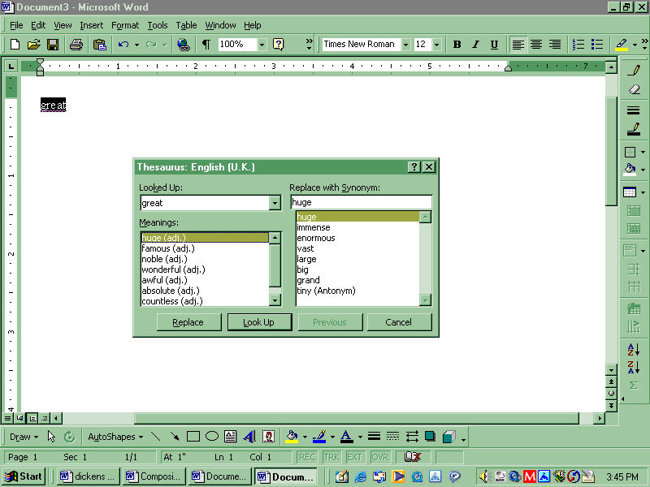
1. Select the word you want to change – here it is great.
2. Press the ‘shift’ key and F7 together (or click on the Tools menu and select Language then Thesaurus)
3. The Thesaurus box opens.
4. If the word has a number of different meanings, these can be selected from the left-hand side.
5. It offers synonyms on the right-hand side.
At the bottom of the list of synonyms there may be one or more antonyms.

Double-click on one of these for more antonyms.

