5 Presenting and performing

iii. access a wider range of media

Send a video or audio-taped presentation about their school life to a school in their twin town

Author | Jim Gardner

What you need

Equipment

The most important things you will need are a video camera, video editing software and a microphone (most cameras will have this built in but sound quality is not always great, so a separate microphone may be preferable). You will also need access to PCs and laptops for storing digital video files, sound files, still images etc. Laptops may be a better option as they provide the opportunity to store files as students work in different locations.

Listed below are typical items you will need.



Webcam
It is possible to film video footage with most webcams and they are the cheapest option. However, image quality will not be as good as that captured on a domestic DV camera or semi-professional camera.

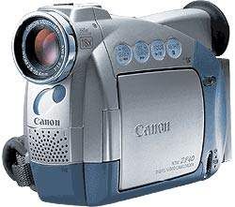

Domestic DV camera
A typical domestic DV camera will provide perfectly good images for use in a video presentation, especially if clips are sequenced and edited well using editing software. You will also need a good tripod. Most filming should take place with a tripod if possible.

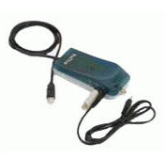
WinTV External video capture card
If students wish to capture images from existing videos or DVDs they will need one of these to import files to their PC or laptop. They may not need to do this but should be allowed to if they wish. They card will come with its own ‘capture’ software.

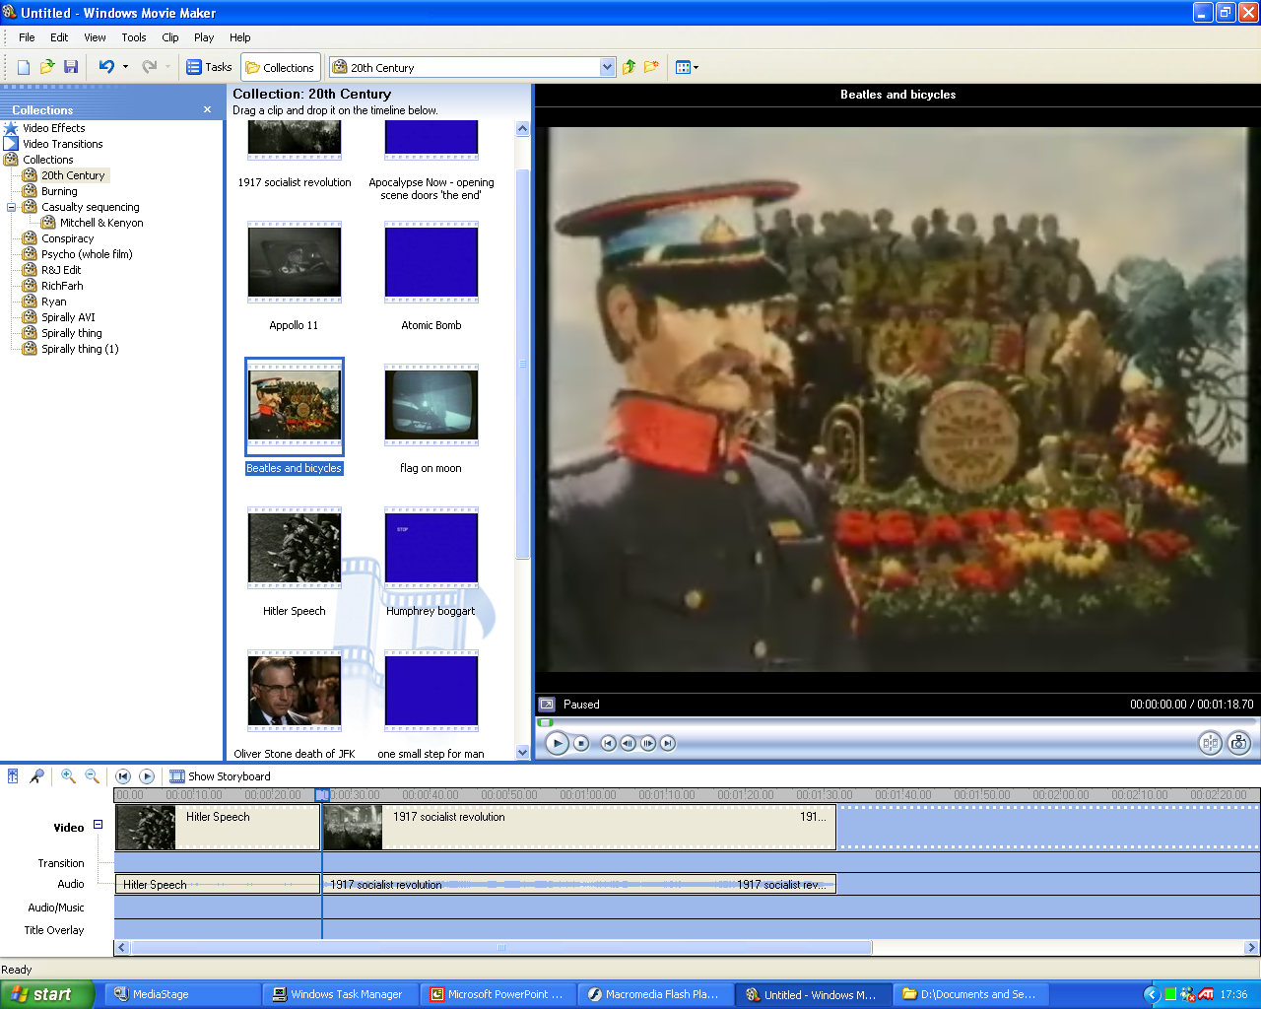

Microsoft Windows MovieMaker software
Windows MovieMaker comes bundled with Windows XP. It is easy to learn how to use and a perfectly good solution for editing in the classroom. It also saves money as you don’t need to buy it if you have XP.

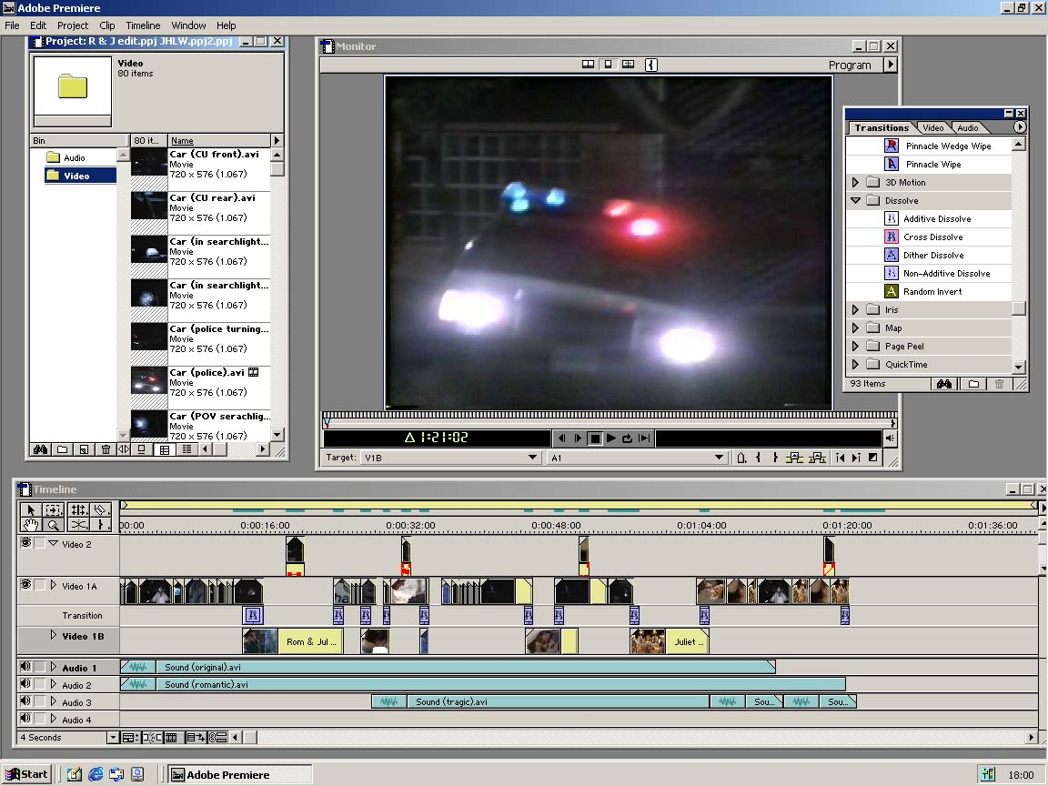
Adobe Premiere
Another video editing software option – which takes a bit longer to get to grips with than MovieMaker. It also costs £200, so if your school does not already have it, this could be prohibitive.

Pupil skills
Pupils will need some initial tuition and guidance in video production. Explore the folder entitled ‘Video Resources’ for various help sheets.

They will also need to learn how to use MovieMaker.

Teacher skills
Teachers will need to acquaint themselves with principles behind good video production and the necessary skills required by pupils for filming and editing.

Resources

Go to ‘Video Resources’ folder where you will find various worksheets that explain technical aspects of capturing video and editing video. There are also sheets in here which introduce students to types of shot and camera technique.

References

Go to ‘Video Resources’ folder

