Writing Online Book Reviews.

Guidance Notes

Description

This lesson activity describes how pupils can write and post an electronic review of a book, which will be visible to other pupils and users of the internet. A detailed example is provided using Amazon, with several alternatives should you wish to avoid using a commercial site.

The activities are designed to tie in with a work of fiction that pupils have read in class. The advantage of writing an online book review is that pupils can engage in a debate outside of their own school, responding to the comments and opinions of other readers, as well as presenting their own thoughts. The other potential advantage is that there is a real audience for the text: namely, potential readers of the book being reviewed.

Target Year Group and NLS/NC Links

These resources are intended for Year 7 pupils, though with minimal adaptation they would work equally well for years 8 and 9.

The following NLS objectives are targeted:
- Reading 12: comment, using appropriate terminology on how writers convey setting, character and mood through word choice and sentence structure
- Reading 18: give a considered response to a play, as script, on screen or in performance, focusing on interpretation of action, character and event
- Writing 19: write reflectively about a text, taking account of the needs of others who might read it
- Speaking and Listening 14: acknowledge other people’s views, justifying or modifying their own views in the light of what others say

Keywords: book review, online, year 7, internet, class discussion, group discussion

What you need

Teacher:

- A web browser with internet access

Pupils:
- A class set of PCs with internet access.
- Basic familiarity with an internet browser (for example Internet Explorer or Netscape).
- A copy of the book being reviewed would be useful, or access to notes in exercise books.

Explanation

The following activities are described in detail in the lesson notes:

- Pupils read the reviews on amazon.co.uk for a text selected by the teacher.
- Using a template, pupils complete their own book review. More able pupils will respond (respectfully!) to the opinions of previous reviewers on Amazon. A template has been provided in MS Word (Writing a book review pupil template.doc).
- Pupils edit and redraft their work, and post it up onto the Amazon web site. Reviews will be visible after approximately 2-3 days.

Variations

The idea would work just as well with a review of an alternative text, such as a film, computer game, or music album.

If you are reluctant to direct pupils towards a commercial website, then there are two excellent BBC alternatives.

BBC North Yorkshire book review site
http://www.bbc.co.uk/northyorkshire/culture/bookclub/reviews/writereview.shtml

This site accepts reviews of around 250-400 words. Reviews are broken into four sections:

- An introductory paragraph
- A short synopsis
- Personal opinion
- A few words on whether the reviewer would recommend the book or not

Pros: the site contains useful hints and tips on reviewing, and a structured template to submit a review.

Cons: the site is moderated, so not every review is published.

BBC Read & Review website
http://www.bbc.co.uk/dna/getwriting/readandreview

Writers submit their work for review. Visitors can browse the categories of writing (such as “short fiction”, “for children”), and submit their reviews. There is a section which sets out the dos and don’ts of reviewing work on the site – it would be a good idea to highlight these to pupils before they start writing a review. It might also be a good idea for the teacher to pre-select a single story for review.

Pros: The site contains good advice on creating a review. Much of the content is bite sized, and can be read in 15-20 minutes. Pupils can submit their own original writing.

Cons: Most work is by unpublished writers, so is unlikely to tie in with a class reading of a text.

Extensions

Pupils could move on to writing their own short pieces of fiction, and submitting them for review on the BBC Read and Review website (see Variations, above).

Advice

Posting a book review on Amazon

This section outlines the practical steps required for pupils to post their completed reviews on Amazon’s website.

URL: www.amazon.co.uk

Step One: search for a book to review. In this example, David Almond’s Skellig is used, as a typical Year 7 text.

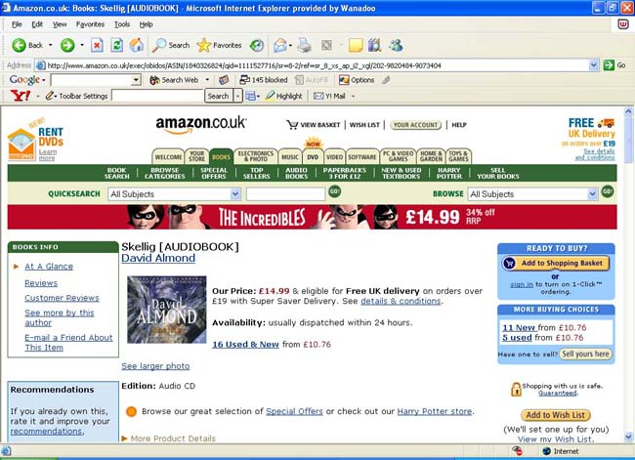
[amazon1_small.jpg]

Step Two: read through the existing reviews for this book. In most cases, there will be a review by Amazon (which is obviously designed to promote the book), followed by reviews from ordinary readers.

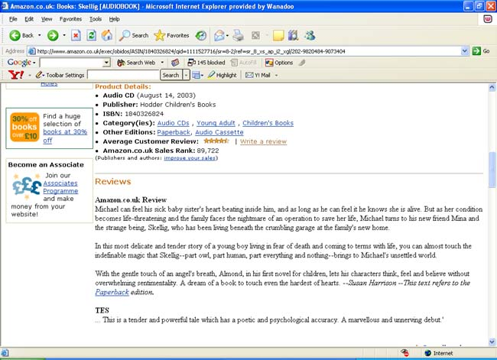
[amazon2_small.jpg]
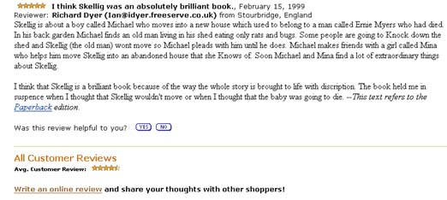
[amazon3_small.jpg]

Step Three: click on “Write an online review” at the bottom of the page. If pupils have not used the site before, they will need to choose a username and password before they can post reviews. NB Pupils do not have to provide any personal information. They do not have to use their real names: they do not even have to provide a real email address. In the example below, a fictitious email address has been supplied.

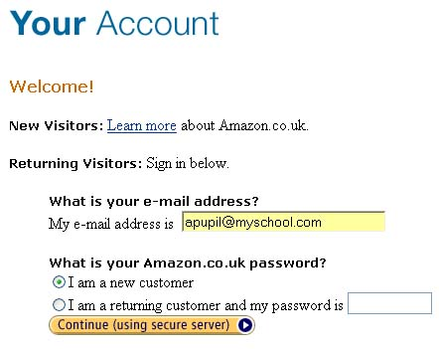
[amazon4.jpg]

Pupils will need to choose their own user name and password. The name does not have to be the pupil’s own name – it could be an abbreviation or nickname (eg Nick S).

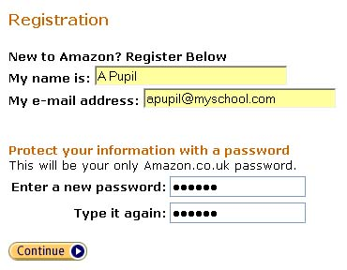
[amazon5.jpg]

After clicking on the “Continue” button, pupils will be taken to the review submission page.

Step Four: post review details. If pupils have completed their reviews in a word processor, such as MS Word, then they can copy and paste them into the review section on Amazon. In most text editors, highlighting the text and pressing CTRL + C will copy the text. Clicking the cursor into the appropriate text box on the Amazon review page, and pressing CTRL + V will paste the text. If pupils have used the Word template provided, they should cut and paste each of the four sections into the same text box.

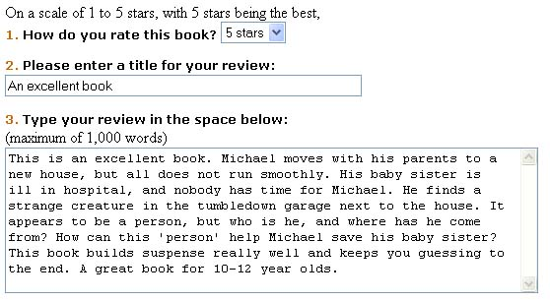
[amazon6.jpg]

Pupils can choose what name appears next to their review (if any). For section 5, pupils could enter their country, region, or school name.

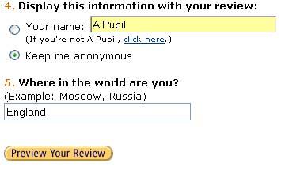
[amazon7.jpg]

Step Five: check and preview. After clicking on “Preview Your Review”, pupils have the opportunity to see how their review will appear on the screen, and to make any final adjustments.

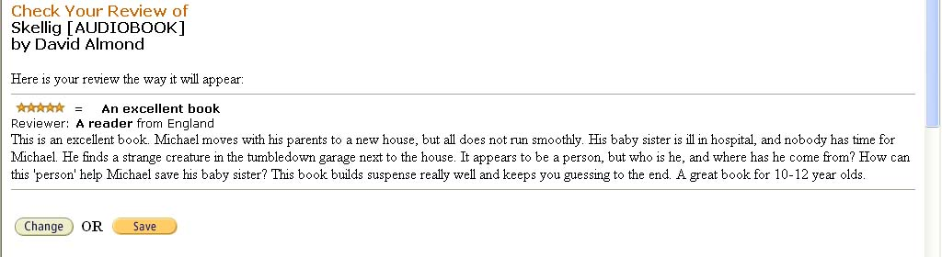
[amazon8.jpg]

Once pupils are happy with their work, they should click on “Save”.

Step Six: submit. After clicking on “Save”, a final confirmation page appears. NB once the review has been submitted, it cannot be changed or removed by the pupil.

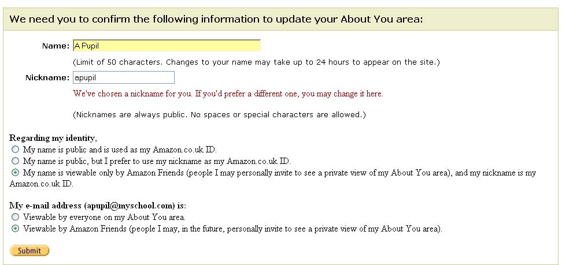
[amazon9.jpg]

Pupils should click on the “Submit” button to submit their review. If asked to confirm how their name or email address is displayed, pupils should accept the defaults as shown above. As already mentioned, if there is any concern in this area, then nicknames and fictitious email addresses can be used.

Lesson notes

NB the activities set out below may well span several lessons, depending on the group.

NLS references | - Reading 12  - Reading 18  - Writing 19  - Speaking and Listening 14
Starter | Pupils go to www.amazon.co.uk in their internet browser.  The teacher will give the pupils a book title to search for.  Pupils should open the information page on the book, and read through the Amazon and reader reviews.  If an interactive whiteboard is available, it would be worth modelling this process.  Feedback: teacher-lead questioning. What are the differences between the Amazon review and the reader reviews? Pupils should identify that the Amazon review is designed to sell the book to a potential customer. Reader reviews should be less biased, and show a greater range of opinions.  Are there any existing reviews which pupils strongly agree or disagree with?
Main activity 1 | Pupils should write their own book review, using the MS Word template (if required) to guide them. This pupil template is called “Writing a book review pupil template.doc”.  Remind pupils that they can respond to existing reviews, as long as they are respectful to the other reviewer. Pupils can also use existing reviews to give them ideas, but the reviews that they submit must be in their own words.  As long as pupils save their work into their personal folder, this activity can span more than one lesson.  Depending on the resources available, pupils could complete the two main activities individually, or in pairs.
Main activity 2 | Pupils should submit their completed review to Amazon. See “Posting a book review on Amazon” in the Advice section for detailed instructions on how to do this.  NB reviews should be no longer than 1,000 words. Pupils should be able to use the word count feature in their text editor to check this. If they are using the Word template, the total word count of the document should not go over 1,125 words – this includes the word count of the prompt questions. Depending on the time available and the ability of your class, you may well want to set a smaller word limit.
Extension | - Pupils could produce a list of the most important elements of a good review.  - Pupils could move on to writing their own short pieces of fiction, and submitting them for review on the BBC Read and Review website (http://www.bbc.co.uk/dna/getwriting/readandreview).
Variations | For an alternative using a non-commercial site, pupils could submit their reviews to the BBC North Yorkshire book review site  (http://www.bbc.co.uk/northyorkshire/culture/bookclub/reviews/writereview.shtml).  More details are contained in the Variations section.

