Section 6: Communicating and collaborating

1. Creating and using a Macbeth class website

Guidance notes

Description

This is not a resource or activity intended for a single lesson: it is a template Macbeth web site, with a discussion of the various ways it could be used and developed in a classroom setting.

It is intended to get teachers and pupils up and running, allowing pupils to focus on developing content and studying the play, rather than worrying about the physical process of creating a website. Very little (or no) previous experience of creating web pages should be required.

There are a number of reasons for creating a website for Macbeth:
- Creating a permanent record of classroom activities. Unlike a traditional classroom display, this can include rich content such as video or audio.
- Creating a study resource.
- Supporting collaborative working.

The classroom activities described later in this document are not necessarily new. The intention of the website template is to support the co-ordination and development of existing good practice. It is the belief of the author that an additional set of skills can be developed and rewarded whilst pupils are working towards a shared outcome. Tasks may be divided amongst different groups within a single class, or between classes in the same year group. For example, one group of pupils may work on creating factual pages on Shakespeare’s theatre, with another group producing a page on the historical figures behind the play. There is no technical reason why collaboration could not take place between schools - although there may be individual time and resource constraints!

Target Year Group and NLS/NC Links

These resources are intended for Year 9 pupils studying Macbeth.

The following NLS objectives are targeted (though this is dependent on the resources that are created for the website):
- Speaking and Listening 10: contribute to the organisation of group activity in ways that help to structure plans, solve problems and evaluate alternatives
- Reading 2: synthesise information from a range of sources, shaping material to meet the reader’s needs
- Reading 4: evaluate the relevance, reliability and validity of information available through print, ICT and other media sources
- Writing 4: choose, use and evaluate a range of presentational devices, on paper and on screen
- Writing 12: exploit the potential of presentational devices when presenting information on paper or on screen, e.g. font size, text layout, bullet points, italics
- Writing 16: present a balanced analysis of a situation, text, issue or set of ideas, taking into account a range of evidence and opinions

Keywords: Macbeth, group work, web site, web page, Internet

What you need

Teacher:

- Web space on your school’s internal or external network.
- Macbeth website files (see File Descriptions section later in this document)
- Web editing software. Microsoft Front Page or Macromedia Dream Weaver are two examples – both are very similar to other Office products.
- Some willing pupils – ideally, you will be able to delegate some of the technical tasks to the pupils themselves!
- A web browser with Internet access

Pupils:
- A class set of PCs with Internet access.
- Basic familiarity with an Internet browser (for example Internet Explorer or Netscape).
- A working knowledge of an HTML editor (such as MS Front Page), or a word processor (such as MS Word).

Explanation

An explanation of this resource is broken into a number of different sections:

- Setting up your website.
- File descriptions.
- Adding a new page.
- Editing an existing page.
- Adding links to the menu.
- Suggested content.

Setting up your website
Your school will probably have its own recommended method of web publishing. Initially, all that you need to do is copy the files provided into a directory on the network that you and the pupils can access.

Most schools will have a separate teacher and pupil area of the network. In this case, you could copy across the entire website directory from the teacher area to the pupil area. In the teacher area of the network, right click on the directory which contains the website, and click on copy:

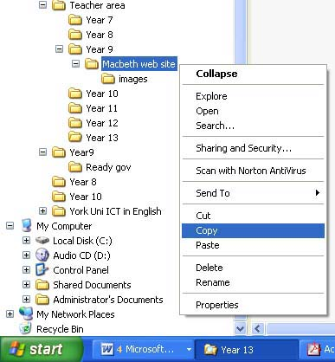
[Macbeth website setup 1.jpg]

In the pupil area of the network, right click on the parent directory within which you want the website to appear, and click on paste:

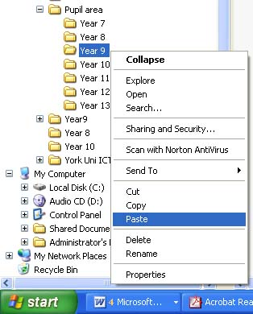
[Macbeth website setup 2.jpg]

Top tip: it would be a good idea to take a copy of the site on a regular basis, on a part of the network the pupils don’t have access to. The last thing you want is a pupil accidentally (or purposefully!) deleting the whole website. Your network manager may already take a backup for you, but it never hurts to be safe. Using the illustration above, you would simply perform the copy and paste in reverse – from the pupil area of the network to the teacher area. Although the possibility of losing work is a worry, this simple precaution would reduce the risk greatly – in any case, the risk is probably a lot less than that of pupils losing or damaging shared paper resources!

File descriptions
The following table explains the purpose of each of the files in the Macbeth website template:

File name | Description
index.htm | This is the page to link to from other pages on your school’s website. You shouldn’t need to change this page as it does not contain any content – it simply loads the site into frames. Don’t edit it unless you know what you are doing!
Menu.htm | This is the menu page that appears on the left hand of the site. This is the page to edit if you want to add, remove or edit a link.
Top.htm | This is the black strip with the Macbeth logo that appears at the top of the page. You can edit this to add your school’s name to the title.
Home.htm | This is the main home page of the site. You will need to add your own welcome and explanation to this page.
History.htm, classdiscussions.htm, keyscenes.htm, performing.htm, revision.htm | These are blank templates, ready for your content.
Menu.css, stylesheet.css | You shouldn’t need to touch these files – they contain the information which sets the font sizes, colours etc that are used on each page.
Images (directory) | This directory contains the images used by the website.

Adding a new page
You and your pupils can create pages in any web page editor. If you don’t have a specific web editor such as Microsoft Front Page, you can use most word processors to create html files. In Microsoft Word, for example, you can save a document as a web page (file -> save as -> save as type ‘web page’).

A good starting point would be to open up one of the blank template files (eg history.htm), and save it with a new name. This will ensure that your pages all have the same basic layout, fonts and colour scheme.

When you have finished, save your page in the same directory as the other .htm files.

If pupils are all working on the same topic (eg Shakespeare’s theatre), it would be a good idea to make them save their pages with different names – for example, pupil initials + file name. You, or the pupils, could then decide which pages should be linked from the rest of the site.

Editing an existing page
Use the file descriptions table above to check which files you are likely to have to edit.

Bear in mind that different pupils cannot be working on the same web page at the same time. Don’t ask all your pupils to edit the same theatre history page at the same time, as changes will be overwritten each time somebody saves.

If you want pupils to work independently on the same content, you could ask them to save a new copy of the file, adding their initials in front of the original file name.

NB: Some word processors (including MS Word) will alter some of the formatting of web pages. This is unlikely to be a problem, but you may notice some minor formatting changes after you edit one of the original template files.

Adding links to the menu
Open menu.htm in your web page editor. Edit the list of links and save your changes.

Suggested content

This is a small flavour of the type of content that could be developed for the website: in many cases the site will provide a repository and focal point for the outcomes from existing classroom activities. As such, you should be able to strike a balance between activities which require greater or lesser IT access.

History
- The historical truths behind Macbeth. The BBC is always a good source - try http://www.bbc.co.uk/history/historic_figures/macbeth.shtml as a starting point.
- The history of witchcraft / Elizabethan attitudes towards witches. The following BBC links might be useful:
  - http://www.bbc.co.uk/history/scottishhistory/union/oddities_union_2.shtml
  - http://www.bbc.co.uk/history/timelines/scotland/berwick_witches.shtml
- Shakespeare's theatre. If you haven't seen it already, the Converse website contains some excellent resources and activities:
  - http://aspirations.english.cam.ac.uk/converse/gcse/shakespeare.acds

Class discussions
Why not start a class discussion group in Google Groups, and link to it from your Macbeth website? Visit http://groups-beta.google.com/groups/create to find out more. There is also a separate resource pack which covers the use of discussion groups in some detail.

Performing Macbeth
The website could act as a repository for drama outcomes that would otherwise be lost. Depending on the level of IT support, and resources, you could include videos of pupil performances, audio extracts, or still images.

For some pupils, producing a product for the website (such as an audio recording of a speech) may provide an additional focus.

Revision guides
You could include a mixture of teacher notes, and pupils’ own revision guides. You could divide the class into groups with a particular focus in order to pool the efforts of the class.

Pupils could compile lists and reviews of useful websites.

