Using discussion groups to support the teaching of Macbeth

Guidance Notes

Description

This lesson activity covers the creation and running of an electronic discussion group. It provides advice on creating the newsgroup, and describes activities and learning outcomes in the classroom.

The advantages of this type of class discussion include:

- The ability to maintain and develop a long running discussion that spans more than one lesson.
- Discussion with other classes or schools.
- Support for less confident oral contributors.
- The ability to keep a permanent, searchable record.

Target Year Group and NLS/NC Links

The lesson activities are aimed at Year 9 pupils studying Macbeth, although the concept of a news group discussion could be adapted for other year groups.

The following NLS objectives are targeted:

- Speaking and Listening 10: contribute to the organisation of group activity in ways that help to structure plans, solve problems and evaluate alternatives
- Reading 5: evaluate their own critical writing about texts
- Reading 10: comment on interpretations of the same text or idea in different media, using terms appropriate for critical analysis
- Writing 13: present a case persuasively enough to gain the attention and influence the responses of a specified group of readers
- Writing 14: make a counter-argument to a view that has been expressed, addressing weaknesses in the argument and offering alternatives
- Writing 16: present a balanced analysis of a situation, text, issue or set of ideas, taking into account a range of evidence and opinions

Keywords: email, news group, internet, group discussion, new technologies

What you need

- A class set of PCs with internet access. Ideally, students would have a PC to themselves, but the activities will also work with one PC between two pupils.
- Email accounts for each pupil, and an email programme (eg Outlook).
- Basic familiarity with an internet browser (for example Internet Explorer or Netscape).
- Familiarity with Macbeth. The extent of pupils’ knowledge will depend on whether the message board discussion is focussed on the play as a whole, or on certain acts, scenes or passages.
- Copies of Macbeth (or internet access to an online text).
- PowerPoint file for starter activity: Formal or informal sort activity.ppt

Explanation

The suggested lesson sequence is as follows:

- Pupils complete the sort activity in the PowerPoint file (Formal or informal sort activity.ppt)
- Pupils access the discussion group (via email, the internet, or using your own software)
- Pupils respond to the discussion topics that have been started by the teacher.
- Pupils respond to each others’ messages.

While pupils are posting messages, they should not be allowed to respond to each others’ messages orally – all discussion should take place electronically.

Variations

This type of electronic class discussion could work with any topic. As a variation, you could allow individuals or groups of pupils to act as moderators and message editors to ensure that the discussion remains on topic.

Extensions

Pupils could summarise the key points of the discussion, or post new topics for further discussion.

Advice

Individual schools may have software which will allow them to create and manage message boards: Microsoft Outlook is one example. However, it is also possible to set up a message board using a number of free internet web sites. Google Groups (http://groups.google.com) will be used as a detailed example. They are free to use, flexible, and do not require any specialist knowledge or software. Using a browser with internet access, instructions will be given for creating a school / year group / class account, adding members and managing topics.

Safety and security

Some simple precautions can ensure that pupils can take part in a message board discussion in safety:

- Make sure your message board can only be seen by your intended audience.
- Make sure your pupils have to be logged on in order to post messages. This means you can trace a message back to an individual.
- Make sure you have an admin account that will allow you to remove any messages that are unsuitable, or off topic.

Elsewhere in this document, Google Groups is used as an example of how to achieve this.

Setting up a newsgroup using Google Groups

There is a small initial amount of time required to get the new group up and running. This should be no longer than 10-15m and only needs to be done once. Hopefully, the group would be used on a regular basis, to justify this modest investment.

From the Google Groups home page (http://groups.google.com), follow the link to create a new group. You will need to be a registered user on Google to do this – follow the prompts if you are not already a registered user. If you already have an account with Google for personal use, it might be a good idea to set up an account for teaching only, so you don’t share your private email address with your pupils.

The first group setup page will look similar to this:

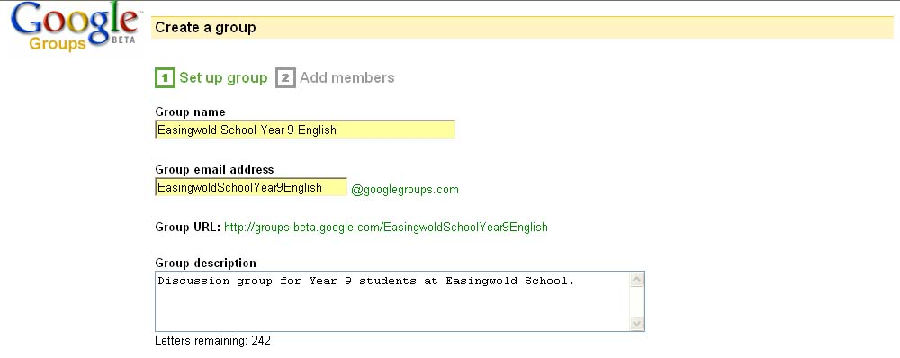[Google groups 1.jpg]
When naming the group it is worth considering who the target audience is: for example, a subject and year group, or a specific class only.

The most important decision to take is the level of access you want to grant to the group. In a school environment, you must ensure that access is restricted – this ensures that you have full control over who can read and post messages. The group will not be publicly visible on the internet.

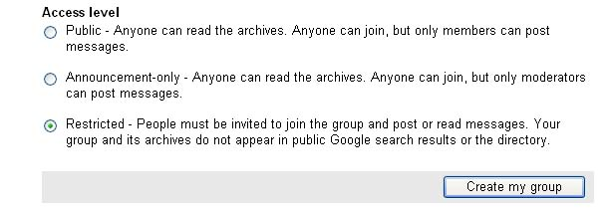[Google groups 2.jpg]
The next step is to add the email addresses of the pupils you want to be able to use this group. To save time, your friendly network manager might be able to give you an electronic list of pupil email addresses that you can cut and paste.

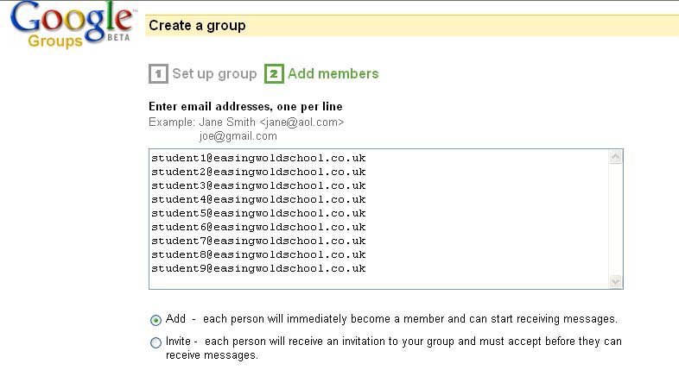 [Google groups 3.jpg]
It is probably best to set the default subscription type to ‘Email’: this way, pupils will receive an email containing each new posting to the group.

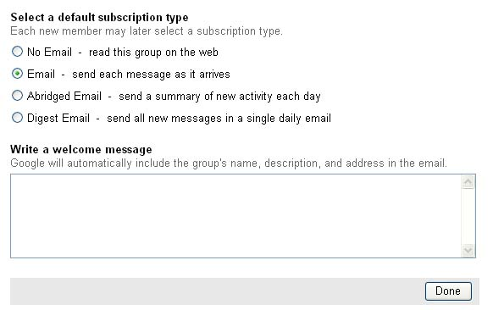 [Google groups 3b.jpg]
Your group should now be ready to use, and you should see a confirmation page of the group’s web and email address.

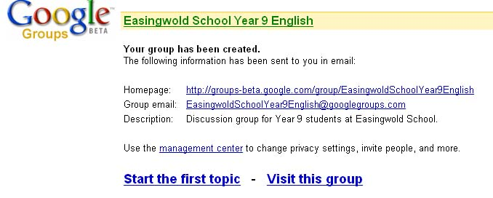
[Google groups 4.jpg]

The management page of your new group will allow you to edit the various settings, including moderation. In a classroom, it is probably best if the group is not moderated. As long as the access to the group is restricted as set out above, then the only people with access to post will be your pupils. Moderation could cause a bottleneck, limiting the ability of pupils to post messages in real time and receive replies within the lesson.

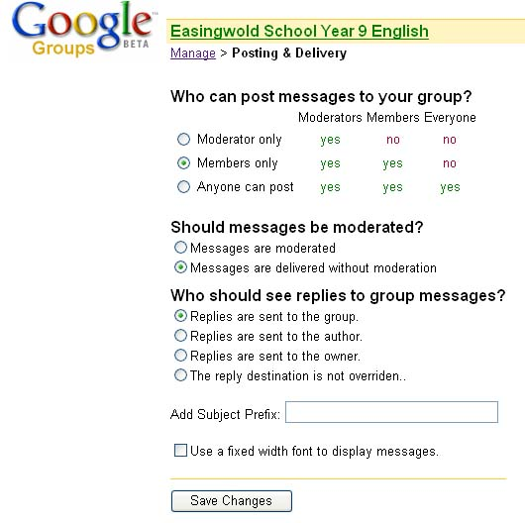
[Google groups 5.jpg]

Starting a new topic in Google Groups

Before the start of the lesson, the teacher should post the topic(s) for discussion. From the homepage for your group, click on ‘Start a new topic.’

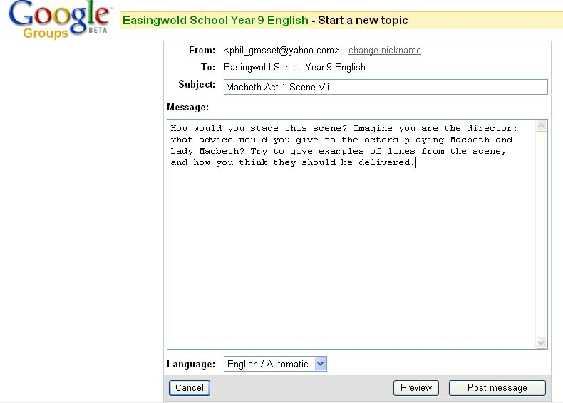
[Google groups 7.jpg]

Viewing and posting messages in Google Groups

There are two ways to view and post messages in Google Groups:

By email. Pupils will receive a copy of each message posted to the group, which they can read in their school email programme. They can reply directly to any of these mails, or they can send a new mail to the email address of the group (in this example, EasingwoldSchoolYear9English@googlegroups.com).

Online. Pupils can go to the web address of the group (in this example, http://groups-beta.google.com/group/EasingwoldSchoolYear9English). The first time they visit the web page, pupils will be prompted to set up a Google account. This requires them to provide their school email address, which will not be visible to anyone on the internet, and to set their own password. This is a fairly straightforward process that should take no more than 2-3 minutes. If you have an interactive whiteboard, you could model this process with one pupil.

Lesson notes

NLS references | - Speaking and Listening 10  - Reading 5  - Reading 10  - Writing 13  - Writing 14  - Writing 16
Starter | Formal or informal? PowerPoint based sort activity (Formal or informal sort activity.ppt).  Pupils should rearrange 5 short extracts from most formal to least formal. Each extract can be dragged and dropped into the required order. If you have an interactive whiteboard, you could do this as a class activity, taking suggestions from the pupils.  The purpose of this activity is to push pupils to consider whether formality is governed more by the situation than by the media. What is the level of formality expected in an online discussion on Macbeth? Many pupils make the assumption that email is an intrinsically informal media.  Feedback from this activity could be teacher-lead oral discussion. A suggested order of formality is:  - Conversation between a teacher and parent  - A proposal of marriage  - A post to an online discussion on Macbeth  - Telephone call to a children’s play area  - Text message to a friend
Main activity | Pupils post replies to a discussion topic posted by the teacher. Depending on the group, it might be a good idea to post several topics.  Open questions will work best, in the same way that they would in an oral class discussion. The discussion topic will depend entirely on your area of study. The following may be useful suggestions:  - What makes Macbeth kill Duncan? Who influences him? To what extent is Macbeth responsible for the murder and his own downfall?  - Why does Macbeth spend so long persuading the assassins to kill Banquo, when he could just order it?  - How would you direct the scene where Macbeth sees Banquo’s ghost?  - Which is the worst of Macbeth’s crimes?  - Why are the witches’ predictions so important to Macbeth?  Pupils should use evidence from the text to support their opinions. Cutting and pasting lines from an online version of the text would be a good idea (eg www.shakespeare-online.com).  Pupils should be prompted to take account of previous postings when they reply. If they agree, or disagree, with a posting they should use evidence to support their view.  Pupils should not be allowed to reply orally to each other – they should reply through the discussion group.
Extension | There are several options for extending the lesson:  - Pupils summarise the main points of the discussion on a topic, and pick out the most convincing arguments. This could be done orally, or as postings to a new topic (eg “Thursday 28th - summary of discussion”).  - Pupils could suggest new topics for a future discussion, or for the remainder of the lesson.  - The teacher could ask pupils to feed back orally on individual postings for clarification or further comment.
Variations | The messages on the discussion group represent a semi-permanent record of the class discussion. In future lessons, it would be possible to return to a previous discussion to re-examine it, or to apply new knowledge, or to summarise as part of a revision exercise. In theory (depending on the pupils!), the discussion group could contain a repository of knowledge.

Glossary

Message board / forum | An electronic message board, which allows a group of people to post and read messages, and to post replies.
Thread | The collective term for a message and its replies.
Moderator | A person who reads and approves / rejects messages before they are posted onto the message board.
Non moderated forum | A forum with no moderator. Messages will appear as soon as they are posted by the author.
Moderated forum | A forum with a moderator. Messages will only appear once they have been approved by the moderator.

