Creating a Word Wall

This tutorial will take you step by step through the process of creating your own word walls.

- First choose your poem:

The Little Boy lost

'Father, father, where are you going?
Oh do not walk so fast!
Speak, father, speak to your little boy
Or else I shall be lost.'

The night was dark no father was there,
The child was wet with dew;
The mire was deep, and the child did weep,
And away the vapour flew.

- Next change the font colour to red by selecting all the text and choosing red from the menu bar (you'll see a big capital A, usually underlined in black. Next to it is a down arrow. Click on that and a range of colours appears. Choose red. Now the A is underlined in red)

The Little Boy lost

'Father, father, where are you going?
Oh do not walk so fast!
Speak, father, speak to your little boy
Or else I shall be lost.'

The night was dark no father was there,
The child was wet with dew;
The mire was deep, and the child did weep,
And away the vapour flew.

- Now select the text again and find the highlighter tool on the menu bar. It looks like this: You need it to be red, so again click on the little down arrow next to it and choose red from the colour selection that appears. Highlight all your text in red. Notice, now you can't see a thing!

The Little Boy lost

'Father, father, where are you going?
Oh do not walk so fast!
Speak, father, speak to your little boy
Or else I shall be lost.'

The night was dark no father was there,
The child was wet with dew;
The mire was deep, and the child did weep,
And away the vapour flew.

- The wall is starting to take shape, but we need to separate the courses of bricks. Simply select your text and choose 1.5 spacing. This can be done two ways. The first is easiest: select the text, hold down the Ctrl key (extreme left of the keyboard nearest you) and keeping it held down press 5. Alternatively, select the text and find the appropriate setting from the menus – Format, Paragraph, Line Spacing, 1.5 lines.

The Little Boy lost

'Father, father, where are you going?
Oh do not walk so fast!
Speak, father, speak to your little boy
Or else I shall be lost.'

The night was dark no father was there,
The child was wet with dew;
The mire was deep, and the child did weep,
And away the vapour flew.

- All we need is to create some spaces between each brick to finish the wall. This is done by replacing the highlighted spaces with unhighlighted ones.

Go to Edit on the menu bar and choose Replace. You should see this on the screen:

Click on the More button. An extra range of choices appears. Type a space in the top Find what: box.

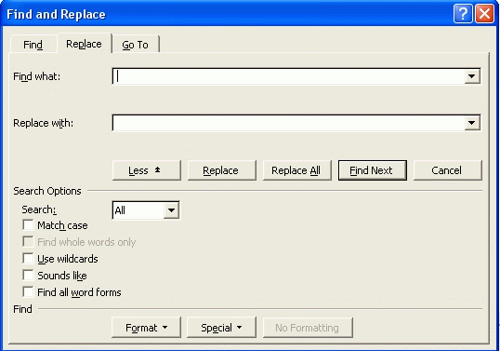

Type a space in the bottom Replace with: box, and click on the Format button. A drop-down menu appears. Select Highlight:
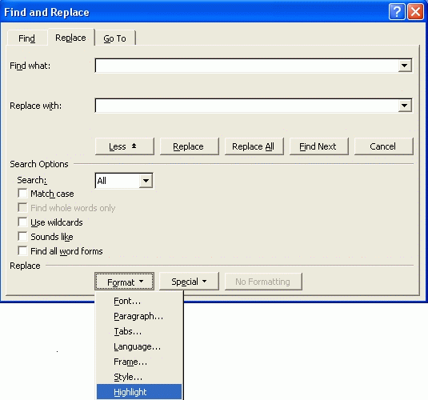
You should see this – the words Format: Highlight under the Replace with box:
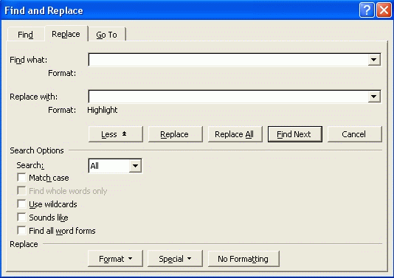

Repeat the last step – Click on Format, select Highlight again. This has the effect of toggling and the words Format: Highlight under the Replace with box now change to Format: Not Highlight. All you need to do now is click on Replace All and the magic trick is done. All your spaces have the highlight switched off in one go.
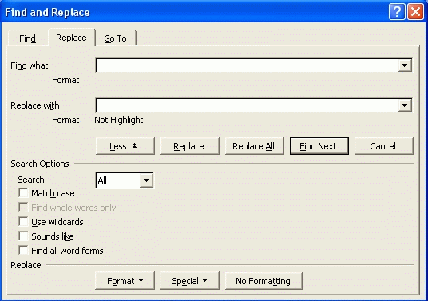

Here's the result:
The Little Boy lost

'Father, father, where are you going?
Oh do not walk so fast!
Speak, father, speak to your little boy
Or else I shall be lost.'

The night was dark no father was there,
The child was wet with dew;
The mire was deep, and the child did weep,
And away the vapour flew.
And there you have it – a fresh Word Wall.
.

