Collapsing a Text

This process involves the reduction of a text to its alphabetical listing. This has the effect of preserving the vocabulary in its entirety, but the meaning is lost. It’s a bit like pulling the string from a patterned necklace of beads – the pattern collapses but the beads remain.

The resulting resource is a focus for language study and has some surprisingly powerful creative applications.

Here’s the recipe:
- Choose a text and copy it into Word, or type it in
- Select the whole text (you can do this by choosing ‘Select All’ from the Edit menu, or you can hold down Ctrl and press the letter A)
- Go to the Edit menu and select Find and Replace
- In the top Find what: box type a space (by pressing the space bar)
- In the bottom Replace with: box type ^p

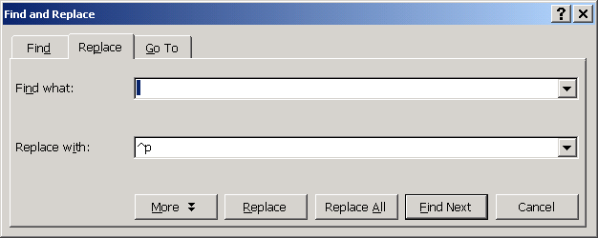

- Click on Replace All
- (this process replaces all the spaces between words with a return character – which is what ^p represents)

You will now see your text as a long, single-word column going down the page. Select this long column using Select All, as before.

Next click on Table from the main icon bar at the top of the page.

Choose AZ Sort (it’s down near the bottom of the list of options).

Voila! Alphabetical listing! Notice all the words have jumped into alphabetical order.

Now you need to reverse the column effect.

Do this by using Find and Replace again, but this time type ^p in the Find what: box and a space in the Replace with box.
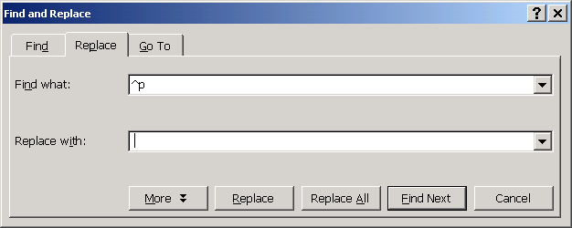

Two things which might prevent it working:
- Make sure there are no spaces left in the top box when you type your ^p
- Make sure you haven’t inadvertently highlighted something while carrying out the process.

