Setting up a sequence of timings with the new Timer
To set up a sequence of timings, first select Teachit Timer. You will see that it has an extra green button below the usual one. Click on that.

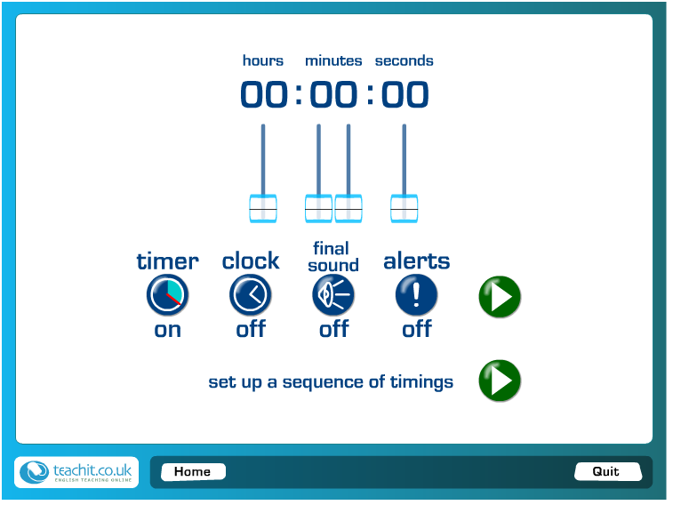
To set up a sequence of timings, click here

The following screen comes up. Simply fill in the table.
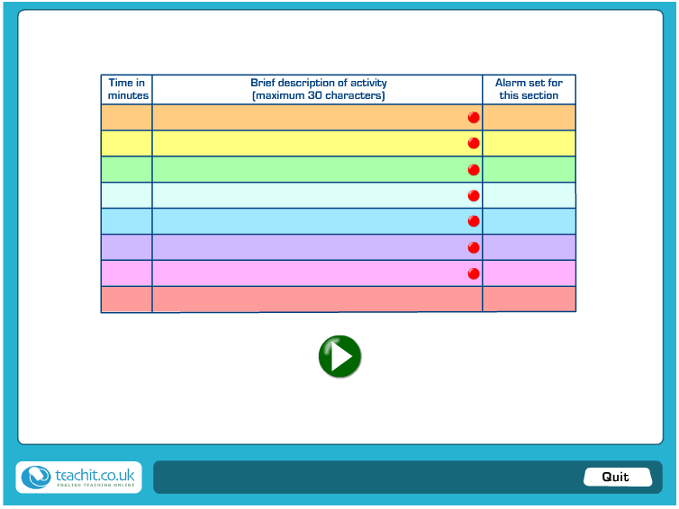
- First fill in number of minutes for the section. This has to be in whole numbers of minutes.
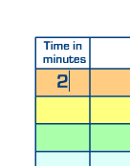
Whole numbers only

- Next fill in the title of the section
Write a short title for each section
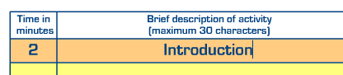

- Select an alarm signal. Just click in the box of the table, and a menu of alarm signals will come up. You can choose the same alarm for each section, or vary the effect, by choosing a different signal. For example, beeps for each subsection and a gong when time is fully up and the session has ended.
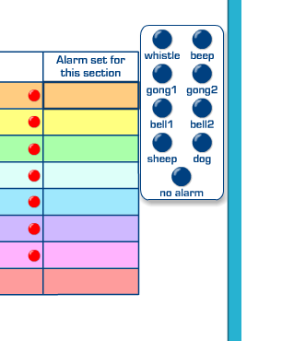
Click in the box to see the range of alarms
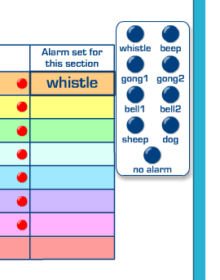
Click on an alarm to select it. Its name will appear in this box
Click on no alarm if you don’t want a sound signal.

- Decide whether you want the session to pause between each section or to run continuously. If you want the timing to pause, the red spot needs to show. If you’d like it to run straight on, the spot needs to show green. To change between the two states, simply click on the spot and it will toggle red or green.

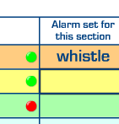
Click on these spots to change between red and green. Red makes the session pause, and you need to click the Go arrow to get it started again. Green allows it to flow on continuously.
A filled-in table as an example, with pauses set between each section:

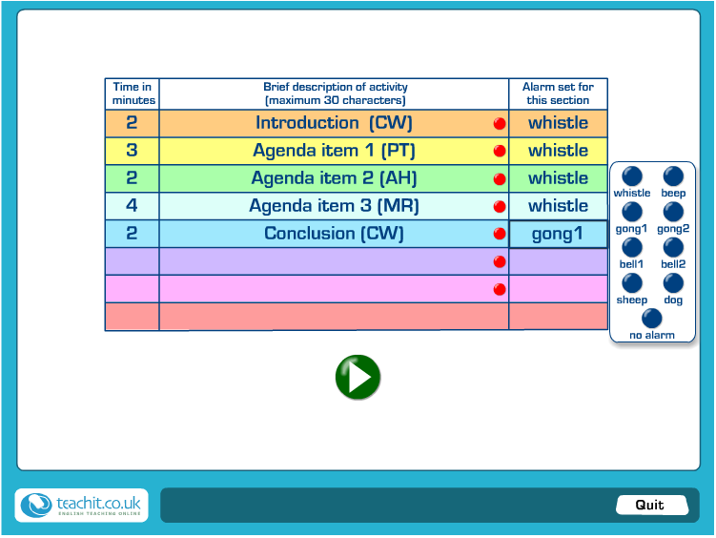
Click here to go to the main session screen

When all the information is complete in the table, click the green arrow button to go to the active timer screen.

NB you must fill in at least one row of the table completely before the sequencer will work. In the example five rows have been filled in, out of a maximum of eight.
This is what the main session screen looks like, using the information in the example above:

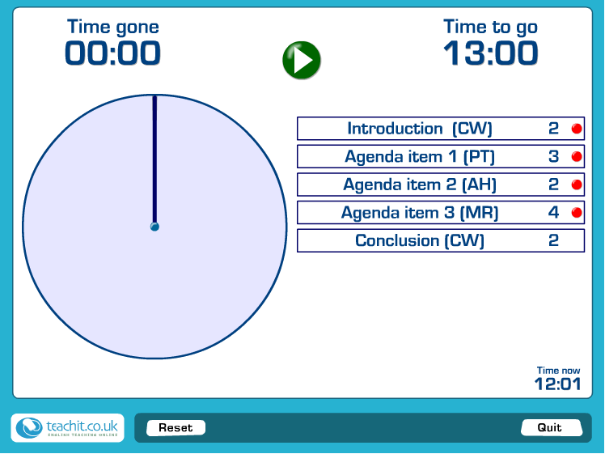
Click here to start the timer.
If you want to adjust how the session runs on the fly, you can toggle between pause and continuous by clicking on the red/green spots,

To start the session, click on the green arrow button. Use the same button to re-start the timer after each pause.

NB you can alter the pause/continuous session spot here too, if you change your mind, or if you suddenly need to speed up.

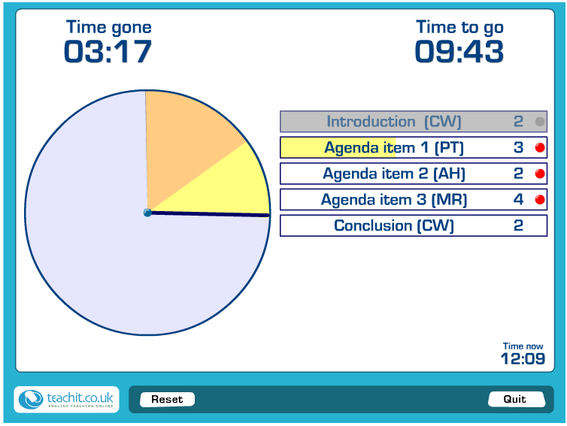
Overall progress is shown in the Time gone and Time to go times at the top of the screen, and the pie-chart.
When a section is complete it turns grey.
Progress through each section is shown on the title bar.

