Four sample applications for the Sequence Timer

Example 1: The typical department meeting.

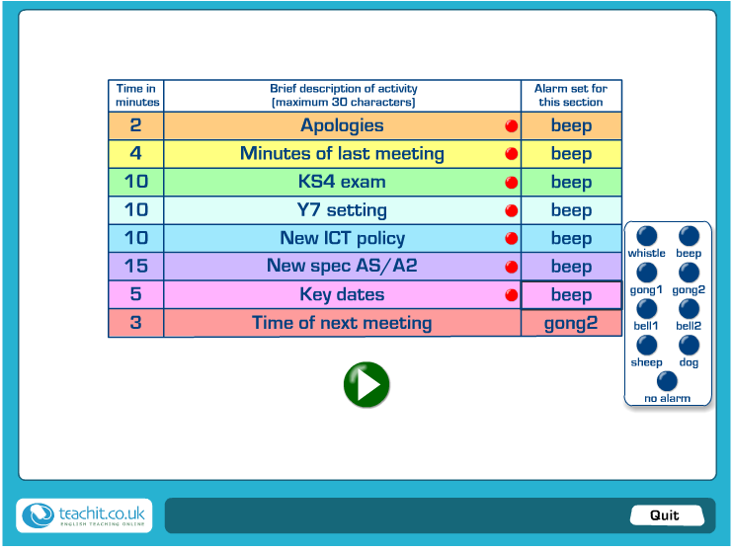
Beeps have been used as more formal.

A gong suitably finishes off the session – perhaps generating a laugh!

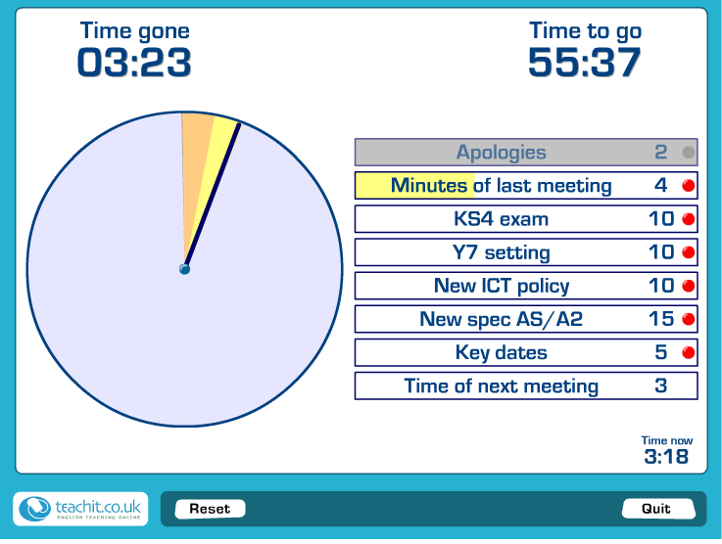
There’s a pause between each item, to allow for slippage and slight overrun
Example 2 –A typical one hour test.

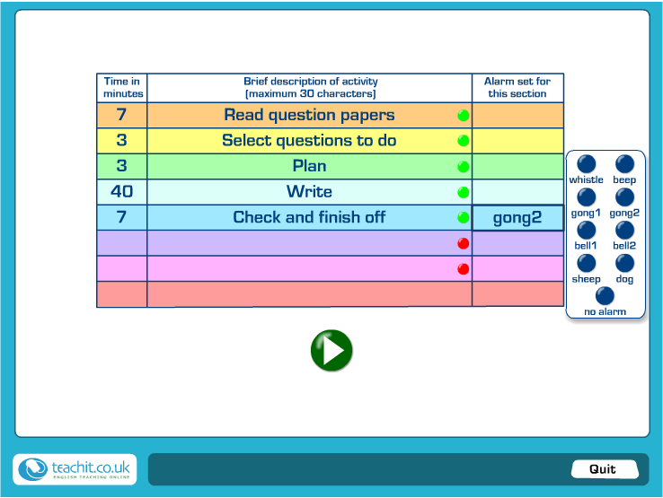
There’s no pause between each item as an exam is continuous.
No alarms – this would be a visual display only, until the end.

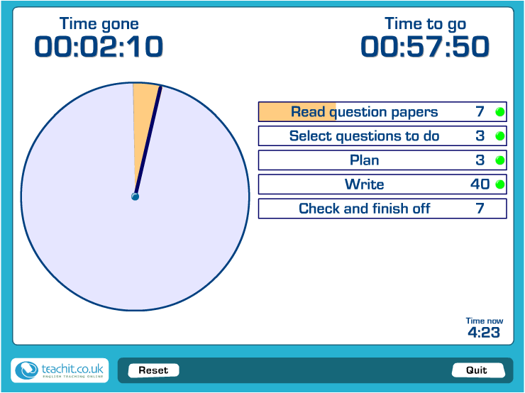

Example 3 – A typical lesson

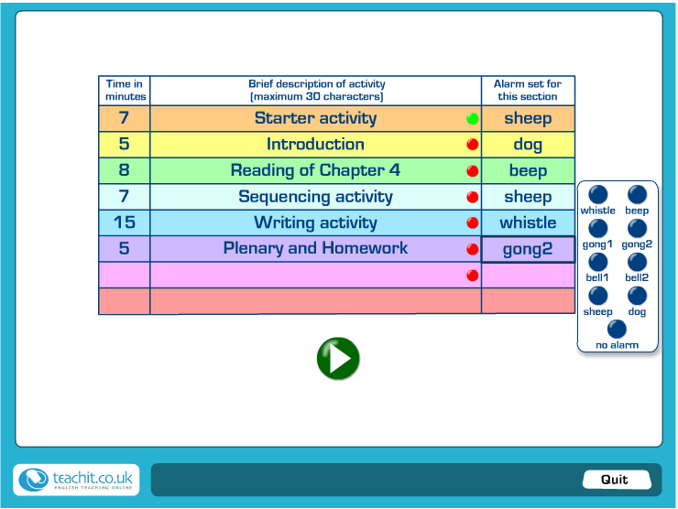
The alarms are a source of amusement as well as a time-keeping device

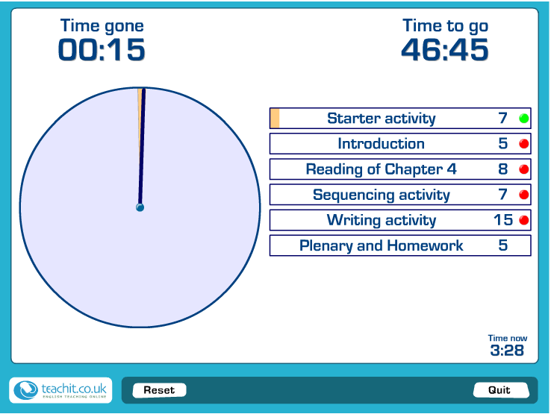

Example 4 – a revision timetable to reinforce self-discipline

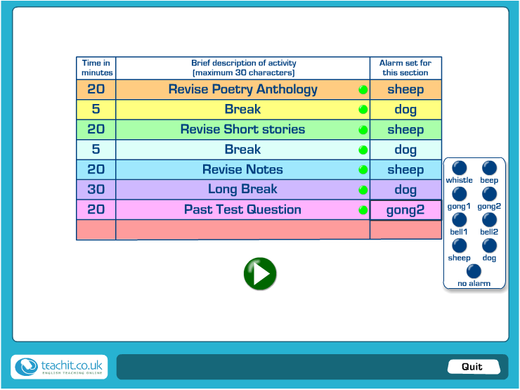
Includes regular short breaks

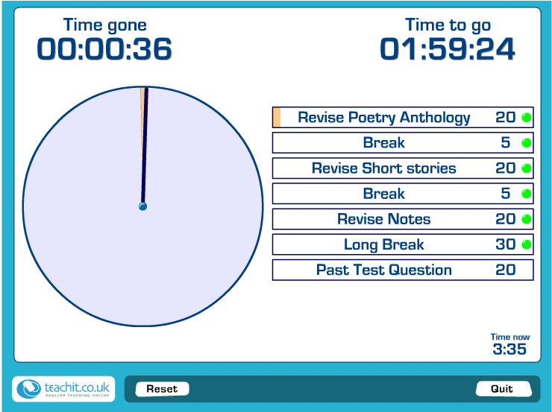
Runs continuously

