Using Audacity (1)

Main Controls:

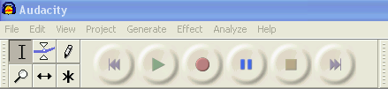
Pause
Play
Time shift tool
Record
Skip to start
Stop
Selection tool
Skip to end

Edit Toolbar:
CutPasteSilenceRedoZoom out
CopyTrim outside selectionUndoZoom in


Recording audio input:

Click on the ‘Record’ button when you are ready to start your input.

When finished click the ‘Stop’ button.

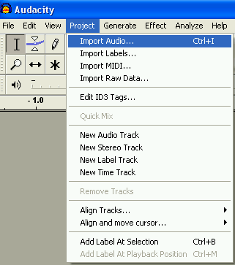
When recording inputs it’s best to record several short tracks rather than one long track.

Importing Audio:

Select ‘Import Audio’ from the ‘Project’ menu

Browse to the relevant folder and select the file you want to
import.

Using Audacity (2)


Playing a track:
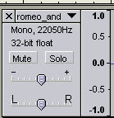
Click the ‘Play’ button to play.

Clicking the ‘Solo’ button will play only the selected track.

Clicking the ‘Mute’ button will stop the selected track from
being played.

Deleting a track:

Clicking on this cross will delete the track permanently.

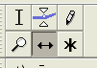
Moving a track:

To move a track along the timeline:

Click on the ‘Time shift’ tool.

Click and hold down the left-hand mouse button and move the track along the line to the desired location.
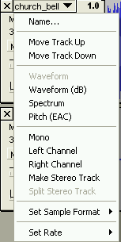
You can change the order of tracks using the track pop-down menu.

Move track up – exchange places with the track above this one.

Move track down – exchange places with the track below this one.

Trimming tracks:

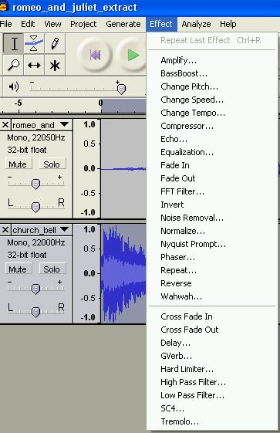
Highlight the section you want to keep and click on ‘Trim outside selection button’
– this will remove everything to the left and right of the selection.

Adding an effect to a track:

Select the track you want to add an effect to and click on the ‘Effect’ menu on the toolbar.

Choose the effect you want from the list.

Using Audacity (3)

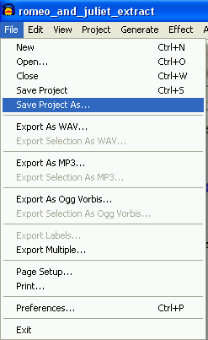
Saving your project:

You will need to save your work so that you can work on it at a later date.

To do this click on ‘File’ on the toolbar and select ‘Save project as’.

Give the file a suitable name and choose an appropriate location to save it in.

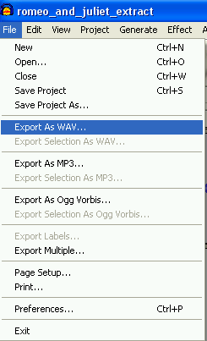

Exporting as a WAV file:

When you have completed your project you can export it as a WAV file – an industry standard format for uncompressed audio.

To do this click on ‘File’ on the toolbar and select ‘Export as WAV’.

NB Before exporting as a WAV file, make sure you have saved your project as an Audacity file (see above).

